Customer: Lukas Thode

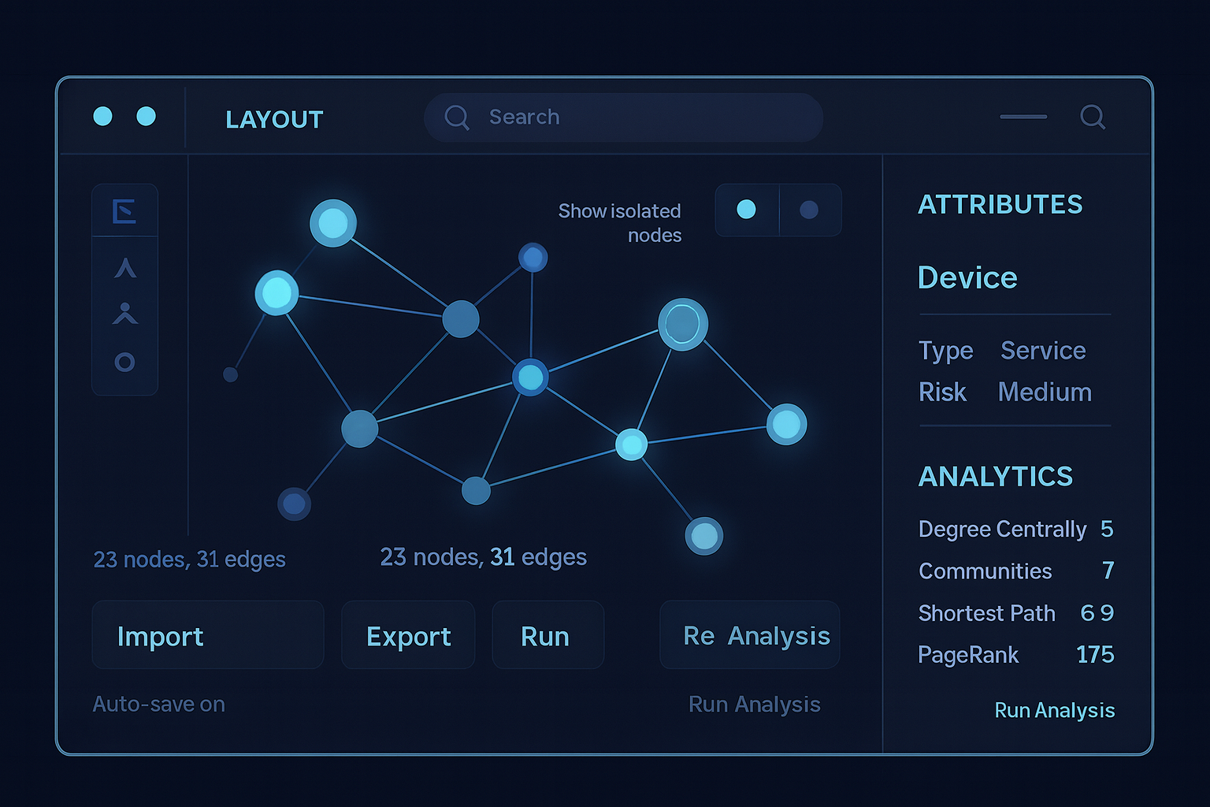Project: Graph Editor

Project summary: Design and build a prototypical, interactive graph visualizer/editor for creating, exploring, and analysing networks (e.g., knowledge graphs, dependencies, social/interactions).

**Core Features:**

1. **Graph editor (web/desktop):** Create/import graphs (CSV/JSON/GraphML), add/delete nodes & edges, edit vertex/edge attributes, undo/redo, versioning.
2. **Layouts & styling:** Force-directed, hierarchical, circular, grid; manual drag/snap; rule-based styling by attributes; mini-map, zoom/pan, theming, dark mode.
3. **Filter, search & query:** Property filters, text search, subgraph extraction, shortest-path finder, neighbourhood expansion.
4. **Analytics:** Degree/betweenness/PageRank, community detection, connected components; highlight results in the view.
5. **Collaboration & sharing:** Annotations/comments, snapshots, shareable links, role-based access; export as PNG/SVG/PDF/GraphML.
6. **Data sources & integrations:** Connectors for Neo4j/PostgreSQL/APIs; live updates/streaming; optional ETL for large imports.
7. **Performance & security:** WebGL/LOD for large graphs, lazy loading, caching; authentication, access control, audit logs.

**Preferred Technology for solution:**

* Javascript with the d3 library.

**Targeted Users:**

* Software engineers trying to visualize complex dependencies between artefacts and documents, e.g. epics, feature, user stories, open-api specs, sw classes, test cases…